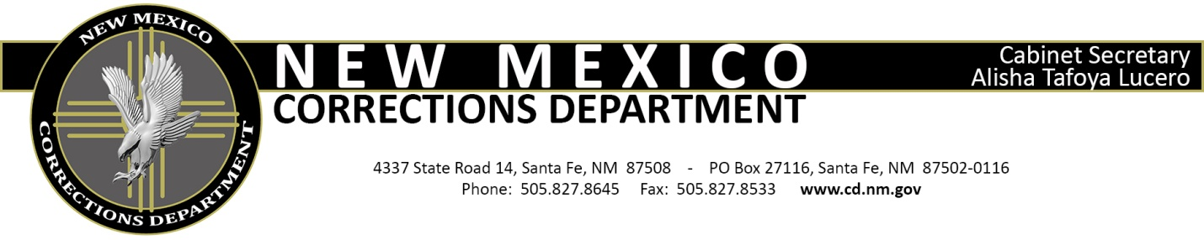

PRISON RAPE ELIMINATION ACT TRAINING ACKNOWLEDGEMENT

Name: _

Facility: Group/Company:
How much time will you spend at the facility in a week's period: _ Training received:
- The Prison Rape Elimination Act;
- NMCD's Policy on Zero Tolerance;
- Reporting incidents of sexual abuse;
- Mandatory Reporters;
- State law 30-9-11.

I understand that if I engage in sexual abuse with inmates, I shall be prohibited from contact with inmates and shall be reported to law enforcement agencies, unless the activity was clearly not criminal, and will be reported to relevant licensing bodies.
By signing this document, I acknowledge that I have received training on my responsibilities under the agencies sexual abuse & sexual harassment prevention, detection, response policies & procedures and I further acknowledge that I understood the training that I received.

Signature Date

cc: Facility PREA Compliance Manager Volunteer Coordinator

